Schedule in Summer
find a job
online courses
read book (MEAN , js)

Front-End Web Developer Nanodegree
1 Intro to HTML and CSS(done)
Because these rules differ sometimes between browsers, there are efforts to promote consistency in styles across browsers. One popular solution to this issue is using what is referred to as a CSS reset such as normalize.css.
Media query, box model, grid, bootstrap
*{
-webkit-box-sizing: border-box;
-moz-box-sizing: border-box;
-ms-box-sizing: border-box;
box-sizing: border-box;
}// elements should have padding and border included in the element's total width and height:

@media only screen and (max-width: 500px) {
p {
background-color: blue;
}
}

.row {
width: 100%;
display: flex;
flex-wrap:wrap;
} // Flex layout so items have equal height, Allow items to wrap into multiple lines *
例子div container ：display: flex; flex-wrap:wrap;
3 个 div box
flexbox： can change the order of elements
@media screen and (min-width: 700px) {
.bule { width: 100%; order: 2;}
.red {width: 50%; order: 1;}
}

git
- feat: a new feature
- fix: a bug fix
- docs: changes to documentation
- style: formatting, missing semi colons, etc; no code change
- refactor: refactoring production code
- test: adding tests, refactoring test; no production code change
- chore: updating build tasks, package manager configs, etc; no production code change

2 Responsive Web Design Fundamentals(done)
emulators, simulators
chrome://inspect/#devices
hardware pixels
(browser) device independent pixels DIP
<meta name="viewport" content="width=device-width, initial-scale=1.0">
img, embed, object, video {
max-width: 100%;
}
nav a, button {
min-width: 48px;
min-height: 48px;
}
<link rel=”stylesheet” media=”screen and (min-widht:500px)” href=”over500.css”>

or

@media screen and (min-width: 500px) {
body { background-color: green;}
}

pattern: column drop, mostly fluid, layout shifter, off canvas

responsive table:
1. hidden columns, *** {display: none}
2. no more tables,
<td data-th=”…”>…</td>
table, thead, tbody, th, td, tr {display: block;}
thead tr {position: absolute; top: -9999px; left: -9999px;}
td {position: relative; padding-left: 50%;}
td:before{position: absolute; left:6px; content: attr(data-th); font-weight: bold;}
3. contained scrolling
div.contained_table{width:100%; overflow-x: auto;}

fonts:

3 Responsive Images(done)

Chrome Canary, chrome://inspect/#
less pixels * better compression = less bytes
img {max-width: 100%;}

img{margin-right: 10px; max-width: 426px; width: calc((100% - 10px) /2);}
img:last-of-type {margin-right: 0;}

{height: 100vh;} {width: 100vw;} // viewport width/height
{width: 100vmin; height: 100vmin;} vmax

raster 栅格图 vector 向量图
grunt imagemagick
background-size: cover
background-size: contain
Unicode <meta http-equiv=”Content-Type” content=”text/html;charset=utf-8”>
<img src=”….” srcset=”a1x.jpg 1x, a2x.jpg 2x” alt=”…”>
img{width: 50vw;}
@media screen and (max-width: 250px) {
img {width: 100vw;}
}
<img src=”….” srcset=”small.jpg 500w, large.jpg 1000w” sizes=”(max-width: 250px) 100vw, 50vw” alt=”…”>

Syntax
There are two flavors of srcset, one using x to differentiate between device pixel ratios (DPR), and the other using w to describe the image's width.

Reacting to Device Pixel Ratio
<img src="image_2x.jpg" srcset="image_2x.jpg 2x, image_1x.jpg 1x" alt="a cool image">

Reacting to Image Width
<img src="image_200.jpg" srcset="image_200.jpg 200w, image_100.jpg 100w" alt="a cool image">

srcset with sizes Syntax
Here's an example:
<img src="images/great_pic_800.jpg" sizes="(max-width: 400px) 100vw, (min-width: 401px) 50vw" srcset="images/great_pic_400.jpg 400w, images/great_pic_800.jpg 800w" alt="great picture">

<picture>
<source media="(min-width: 650px)" srcset="kitten-large.png">
<source media="(min-width: 465px)" srcset="kitten-medium.png">
<img src="kitten-small.png" alt="Cute kitten">
</picture>

- alt attributes should be descriptive for important images, like this body surfer. Because body surfing is important, I guess.
- alt attributes should be empty for images that are just decorations, like this boiler image. Do you get the joke? It's a boiler to represent boiler plate code, which is sometimes empty of content.
- alt attributes should be set on every image, just like this pig is set on being so darn cute.

4 JavaScript Basics(done)====➔google map
There are only six falsy values in JavaScript so it is easiest to memorize those:
- false
- 0 (zero)
- "" (empty string)
- null
- undefined
- NaN
- NaN, or Not a Number, is a value that turns up when we ask Javascript to do certain impossible things in arithmetic -- like divide zero by zero. 0/0
- Infinity and -Infinity. number / 0

undefined means "that a variable doesn't exist and the interpreter doesn't know what you're referring to." This isn't quite true. If you try to use a var that hasn't been defined, you get a ReferenceError. You will see undefined if you declare a variable but don't assign it any values. Like so:
var a; a;
will result in undefined. But
b;
will result in a ReferenceError because b hasn't been declared yet.

no class in JS, only object!
JavaScript Object Notation
When you use three equal signs, ===, no type conversion is done prior to the comparison. If the values are different types, for example, a String and a Number, they can't ever be equal. To return true, the values must be equal and the types must be the same.
Loose equality, ==, checks to see if the two values are the same type and if not, converts to a common type before the conversion. If the types are already the same, there is no difference between the result of === and ==. When they aren't it can cause unexpected results.

5 Intro to jQuery (done)
parent(), parents(), children() find() siblings() find(*)➔all children
toggleClass() first() next() attr() css()
html() text() val()
remove() append() prepend() insertBefore() insertAfter()
each(function)
function someFunction() { // Do interesting things } $(someFunction)
or
$(function(){ // Do interesting things })
chrome : monitorEvents
on(event, action callback)
$( 'article' ).on( 'click', function( evt ) { $( evt.target ).css( 'background', 'red' ); });
evt.preventDefault(); line instructs the browser not to perform the default action.
- event.keyCode to learn what key was pressed - invaluable if you need to listen for a specific key
- event.pageX and event.pageY to know where on the page the click occurred - helpful for analytics tracking
- event.type to find what event happened - useful if listening to a target for multiple events
- $( 'article' ).on( 'click', function() { $( 'body' ).addClass( 'selected' ); }); $( 'body' ).append( '<article> <h1>Appended Article</h1> <p>Content for the new article </p> </article>' );
- Clicking on the "appended" article will not add a class to the body because the "appended" article was created after the event listeners were set up.
- $( '.container' ).on( 'click', 'article', function() { … });
...this code tells jQuery to watch the .container element for clicks, and then if there are any, check if the click event's target is an article element. Event Delegation

6 Object-Oriented JavaScript(done) ➔Frogger Game
Scopes and Closures
only function create a new scope. no var for variable declaration is global variable.
Execution Contexts
this
var fn = function(a, b) {log(this, a, b)};
r.method = fn
r.method.call(y, g, b)
setTimeOut
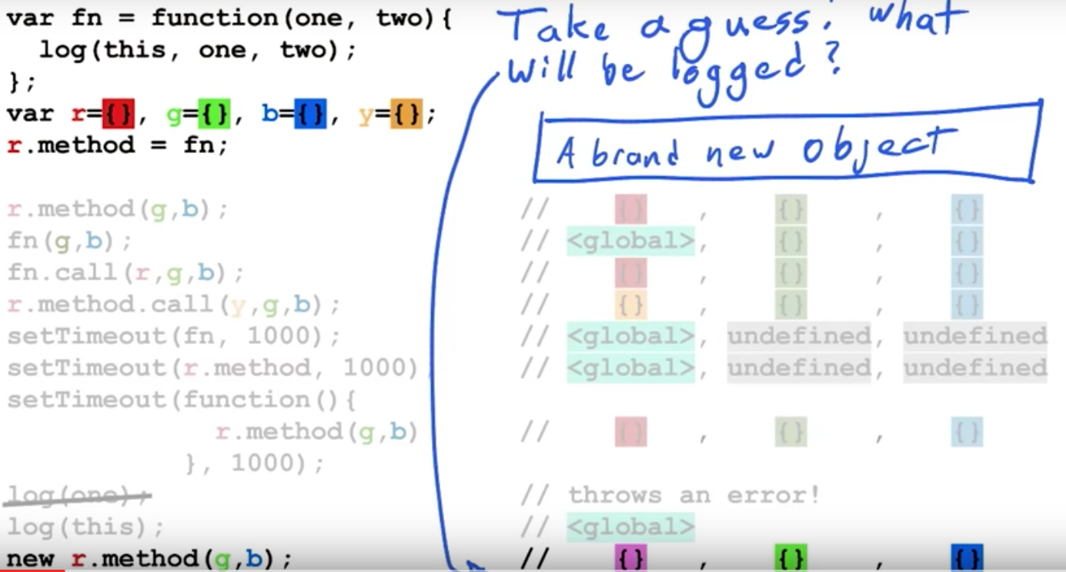
prototype chains
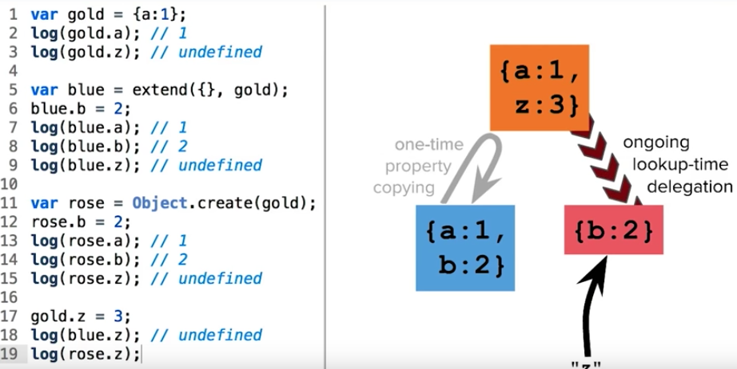
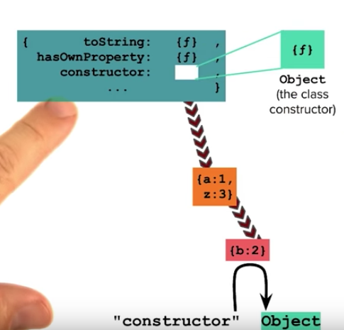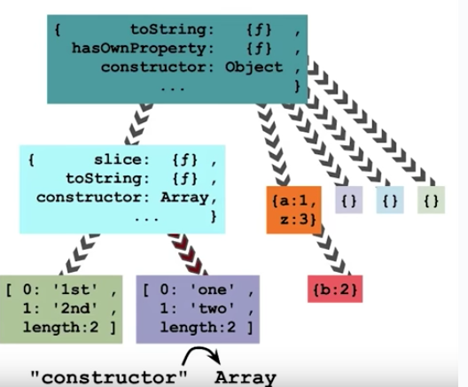
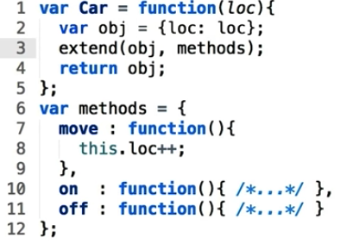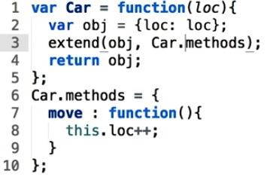
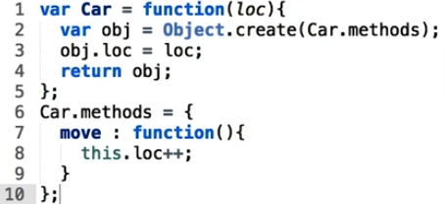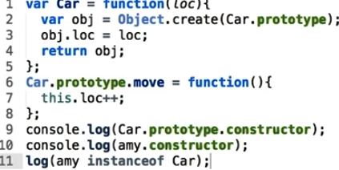

new ➔ constructor mode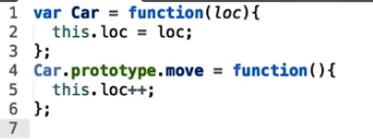
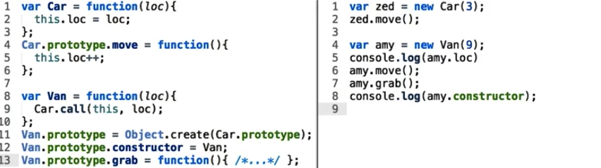

7 HTML5 Canvas(done)
python -m SimpleHTTPServer
http://0.0.0.0:8000/index.html
see code in note

8 Website Performance Optimization(done)
chrome canary
chrome://inspect/#
critical rendering path
curl http://www.udacity.com
characters➔tokens➔nodes➔DOM
characters➔tokens➔nodes➔CSSOM
render tree: only capture visible content (display: none)
layout (<meta name=”viewport” content=”width=device-width”>)
paint
render blocking: keeping the page from loading as quickly as it could.
<script src=”…” async></script> Does not block DOM construction, Does not block on CSSOM
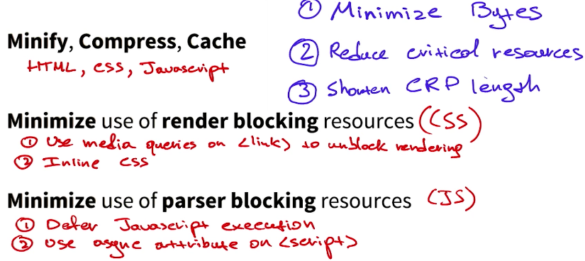
preload scanner

9 Browser Rendering Optimization(?)
60 Hz 60fps
load → idle → animate→ response
FLIP first last invert play

10 Intro to AJAX(done)
Asynchronous JavaScript and XML request
Cross-Origin ResourceSharing (CORS).
JSON-P is a unique trick to allow cross-domain requests.
$.getJSON $.ajax

Cross-origin request sharing (CORS):
cross-site request forgery (CSRF)

11 JavaScript Design Patterns
IIFE (Immediately-Invoked Function Expression,
console.dir(object) is a function that you can use in modern web browsers to display a list of the properties of the specified JavaScript object.

12 JavaScript Testing

Senior Web Developer Nanodegree
1 Building High Conversion Web Forms

2 Web Tooling & Automation

3 JavaScript Promises

4 Offline Web Applications

5 Web Accessibility coming Q1 2016.

6 Component-Oriented Development coming Q2 2016.

Full Stack Web Developer Nanodegree
1 Programming Foundations with Python
2 Intro to Relational Databases
3 Full Stack Foundations
4 Authentication & Authorization: OAuth
5 Developing Scalable Apps in Python
6 Linux Command Line Basics
7 Configuring Linux Web Servers

